Exercise 1 (10 marks)
Please complete and submit the following exercises prior to leaving the lab today.
- (3 marks) Define each of the following terms:
  - IP Address
  - DNS
  - Domain Name
- (3 marks)The image below describes how IP addresses, domain names, and DNS work together.
Label the following items on the image:
  - Client
  - Web server
  - DNS server
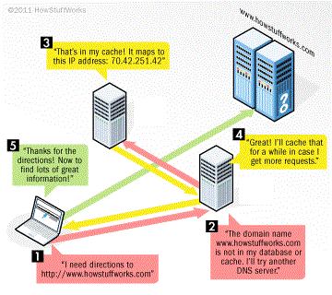
- (4 marks) Open up Command Prompt on your computer. You can find this under the start menu by typing cmd. On the command line type ipconfig and hit enter. This command then queries your machine’s network adapter for its IP address.
  - What is your machine’s IP address?
  - When is a private IP address used primarily?
  - Use Wikipedia or Google to determine if this IP address is a public or private IP address. Which type of IP address is it?

